# *Web Programming III (420-C30-HR)*

# *Assignment 3 – PHP Email List*

Date assigned: Wednesday, November 2, 2016

Date due: **Wednesday, November 16, 2016**

**Learning Objectives**

Upon successful completion of this assignment, the student will be able to:

* Create a web application using an All-in-One form for PHP

To do:

1. Make sure you use CSS to format your web pages. There are marks awarded for design, so make sure it looks professional.

The Application

1. Create a page that allows a user to register with a website. Call the page NewAccount.php. It should look similar to the one in Figure 1 (but I’m sure yours will look nicer). Use your own formatting to design the page. All formatting **MUST** be done using CSS in an external style sheet.
2. Create functions that validate the data and store the validated data in a file customers.txt in the same folder. The following conditions must be met:
   1. Do some basic error checking. You must ensure:
      1. None of the fields are empty;
      2. That the two passwords are the same
      3. That the format of the email address is correct (use a regular expression)
      4. That the format of the phone number is correct (use a regular expression and just one format of phone number: xxx-xxx-xxxx).
      5. The format of the postal code is correct (A1A 1A1) (convert lower case to uppercase automatically for the user).
   2. The error checking must be done in functions that are called in the same page. That is, check if the form has been submitted and, if it has, do the appropriate error checking using the functions (which are in the external file).
   3. Error messages must be displayed for all fields in error at the same time.
   4. Error messages must be display in red at the top of the page (below the header), with the appropriate field highlighted in red and with the entered information displayed (so that the person can edit it).
   5. When the account has been validated, save it to the file so that each line in the file contains the email address, password, first and last names, street address, city, province, postal code and phone number separated by a “~”. An example of the file is shown in Figure 2.
   6. When the account has been saved, display the page with a message indicating that the account has been created. A sample is found in Figure 3. The continue button goes back to the NewAccount.php page.
3. This should be done using only one php file called NewAccount.php. ALL FUNCTIONS MUST BE IN AN EXTERNAL FILE CALLED AccountFunctions.inc and be properly included in the NewAccount.php file.

You should not need to use the echo command to display the forms or data. Rather, end one php code block, display the form in HTML and start another php block.

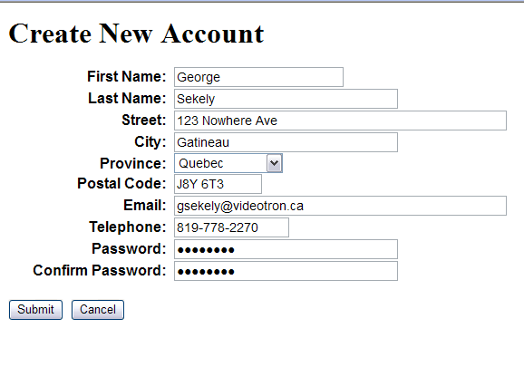

Figure 1: New Account form

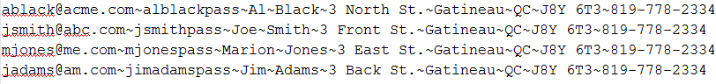

Figure 2: User Output File



Figure 3: Successful Account Creation

**To submit**

When you have completed the assignment, zip the files as YourUserName_C30_A03 and save the zip file to the page for the course.